|  |  |
| --- | --- |
| **PROJECT NAME:** | CONTAINMENT ZONE ALERTING APP |
| **NAME:** | THARMARAJAN S |
| **ROLLNO:** | 921319104210 |

**Assignment -2**

**1.Create User table with email, username, roll number, password.**

CREATE TABLE user (

roll_number int,

username varchar(300),

email varchar(300),

password varchar(300)

);

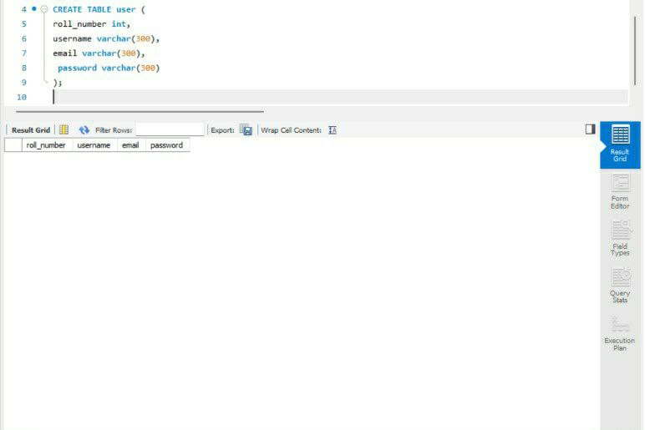

**2.Perform UPDATE, DELETE Queries with user table INSERT Statement:**

INSERT INTO user

( roll_number, username ,email, password) VALUES (1, 'Tharma', 'Tharma@gmail.com','thar123'),

(2, 'Shyam', 'shyam@gmail.com','shyam345'),

(3, 'Veera', 'veera@gmail.com','veera567'),

(4, 'Vignesh', 'vignesh@gmail.com','vignesh789');

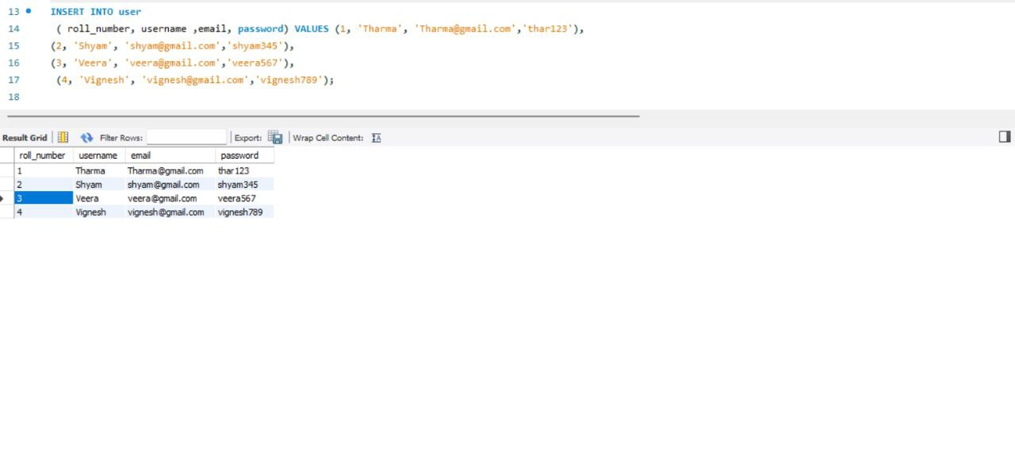

UPDATE Statement:

UPDATE users

SET username = 'shyam chander'

WHERE roll_number = '2'

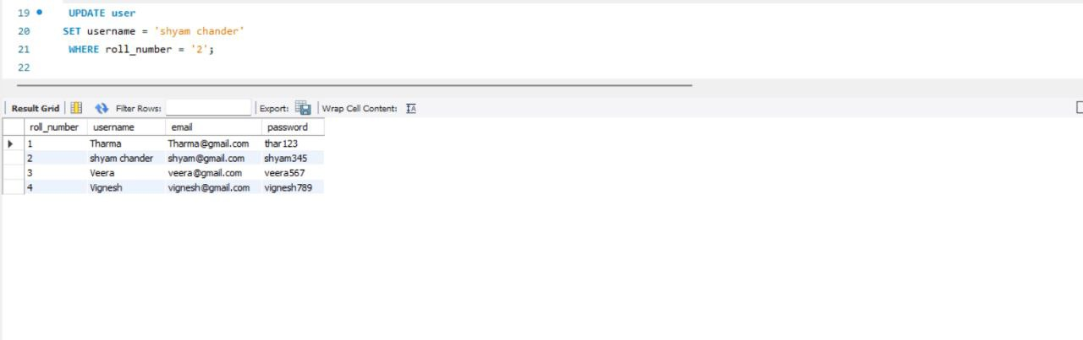

insert into users values(5,'abc','abc@gmail.com','abc012') ;

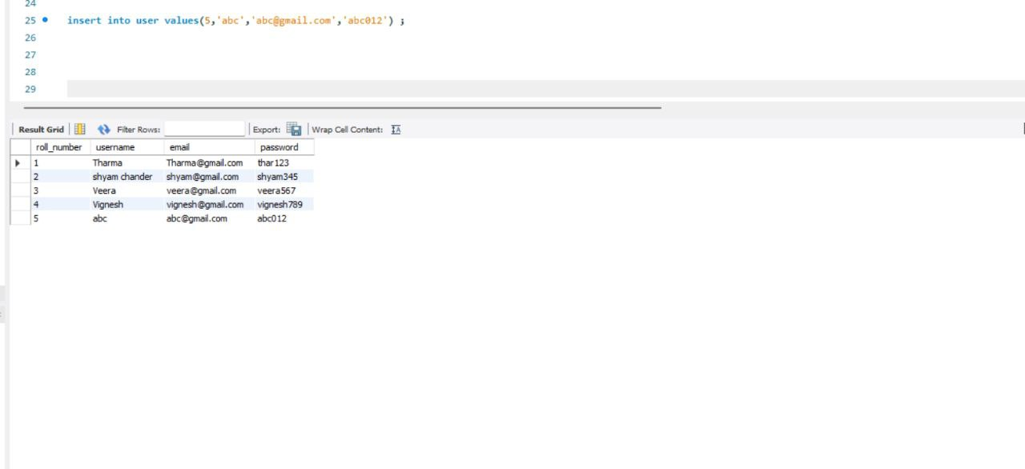

DELETE Statement:

delete from users

where roll_number='5'

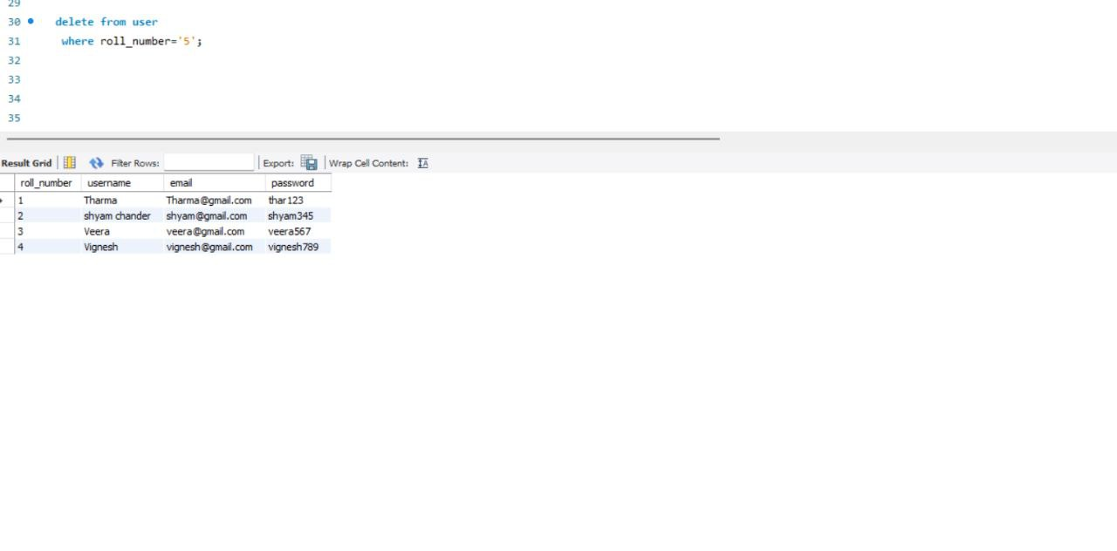

**3.Connect python code to db2.**

conn=ibm_db.connect("DATABASE=BLUDB;

HOSTNAME=dashdb-txn-sbox-yp-dal09-04.services.dal.bluemix.net;

PORT=50000;;UID=DB2USER;PWD=db2password;",",")

**4. Create a flask app with registration page, login page and welcome page. By default load the registration page once the user enters all the fields store the data in database and navigate to login page. Authenticate user with username and password. If the user is valid show the welcome page.**

**login.html**

<**html**>

    <**head**>

        <**meta** charset="UTF-8">

        <**title**> Login </**title**>

        <**link** rel="stylesheet" href="{{ url_for('static', filename='style.css') }}">

    </**head**>

    <**body**></**br**></**br**></**br**></**br**></**br**>

        <**div** align="center">

          <**div** align="center" class="border">

             <**div** class="header">

                <**h1** class="word">Login</**h1**>

             </**div**></**br**></**br**></**br**>

            <**h2** class="word">

                <**form** action="{{ url_for('login') }}" method="post">

                  <**div** class="msg">{{ msg }}</**div**>

                    <**input** id="username" name="username" type="text" placeholder="Enter Your Username" class="textbox"/></**br**></**br**>

                    <**input** id="password" name="password" type="password" placeholder="Enter Your Password" class="textbox"/></**br**></**br**></**br**>

                    <**input** type="submit" class="btn" value="Sign In"></**br**></**br**>

                </**form**>

            </**h2**>

            <**p** class="bottom">Don't have an account? &nbsp<**a** class="bottom" href="{{url_for('register')}}"> Sign Up here</**a**></**p**>

          </**div**>

        </**div**>

    </**body**>

</**html**>

<**html**>

    <**head**>

        <**meta** charset="UTF-8">

        <**title**> Login </**title**>

        <**link** rel="stylesheet" href="{{ url_for('static', filename='style.css') }}">

    </**head**>

    <**body**></**br**></**br**></**br**></**br**></**br**>

        <**div** align="center">

          <**div** align="center" class="border">

             <**div** class="header">

                <**h1** class="word">Login</**h1**>

             </**div**></**br**></**br**></**br**>

            <**h2** class="word">

                <**form** action="{{ url_for('login') }}" method="post">

                  <**div** class="msg">{{ msg }}</**div**>

                    <**input** id="username" name="username" type="text" placeholder="Enter Your Username" class="textbox"/></**br**></**br**>

                    <**input** id="password" name="password" type="password" placeholder="Enter Your Password" class="textbox"/></**br**></**br**></**br**>

                    <**input** type="submit" class="btn" value="Sign In"></**br**></**br**>

                </**form**>

            </**h2**>

            <**p** class="bottom">Don't have an account? &nbsp<**a** class="bottom" href="{{url_for('register')}}"> Sign Up here</**a**></**p**>

          </**div**>

        </**div**>

    </**body**>

</**html**>

<html>

<head>

<meta charset="UTF-8">

<title> Login </title>

<link rel="stylesheet" href="{{ url_for('static', filename='style.css') }}">

</head>

<body></br></br></br></br></br>

<div align="center">

<div align="center" class="border">

<div class="header">

<h1 class="word">Login</h1>

</div></br></br></br>

<h2 class="word">

<form action="{{ url_for('login') }}" method="post">

<div class="msg">{{ msg }}</div>

<input id="username" name="username" type="text" placeholder="Enter Your Username" class="textbox"/></br></br>

<input id="password" name="password" type="password" placeholder="Enter Your Password" class="textbox"/></br></br></br>

<input type="submit" class="btn" value="Sign In"></br></br>

</form>

</h2>

<p class="bottom">Don't have an account? &nbsp<a class="bottom" href="{{url_for('register')}}"> Sign Up here</a></p>

</div>

</div>

</body>

</html>

**register.html**

<**html**>

    <**head**>

        <**meta** charset="UTF-8">

        <**title**> Register </**title**>

        <**link** rel="stylesheet" href="{{ url_for('static', filename='style.css') }}">

    </**head**>

    <**body**></**br**></**br**></**br**></**br**></**br**>

        <**div** align="center">

          <**div** align="center" class="border">

             <**div** class="header">

                <**h1** class="word">Register</**h1**>

             </**div**></**br**></**br**></**br**>

            <**h2** class="word">

                <**form** action="{{ url_for('register') }}" method="post">

                  <**div** class="msg">{{ msg }}</**div**>

                    <**input** id="username" name="username" type="text" placeholder="Enter Your Username" class="textbox"/></**br**></**br**>

                    <**input** id="password" name="password" type="password" placeholder="Enter Your Password" class="textbox"/></**br**></**br**>

                    <**input** id="email" name="email" type="text" placeholder="Enter Your Email ID" class="textbox"/></**br**></**br**>

                    <**input** type="submit" class="btn" value="Sign Up"></**br**>

                </**form**>

            </**h2**>

            <**p** class="bottom">Already have an account? &nbsp<**a** class="bottom" href="{{url_for('login')}}"> Sign In here</**a**></**p**>

          </**div**>

        </**div**>

    </**body**>

</**html**>

<html>

<head>

<meta charset="UTF-8">

<title> Register </title>

<link rel="stylesheet" href="{{ url_for('static', filename='style.css') }}">

</head>

<body></br></br></br></br></br>

<div align="center">

<div align="center" class="border">

<div class="header">

<h1 class="word">Register</h1>

</div></br></br></br>

<h2 class="word">

<form action="{{ url_for('register') }}" method="post">

<div class="msg">{{ msg }}</div>

<input id="username" name="username" type="text" placeholder="Enter Your Username" class="textbox"/></br></br>

<input id="password" name="password" type="password" placeholder="Enter Your Password" class="textbox"/></br></br>

<input id="email" name="email" type="text" placeholder="Enter Your Email ID" class="textbox"/></br></br>

<input type="submit" class="btn" value="Sign Up"></br>

</form>

</h2>

<p class="bottom">Already have an account? &nbsp<a class="bottom" href="{{url_for('login')}}"> Sign In here</a></p>

</div>

</div>

</body>

</html>

**index.html**

<html>

    <head>

        <meta charset="UTF-8">

        <title> Index </title>

        <link rel="stylesheet" href="{{ url_for('static', filename='style.css') }}">

    </head>

    <body></br></br></br></br></br>

        <div align="center">

          <div align="center" class="border">

             <div class="header">

                <h1 class="word">Index</h1>

             </div></br></br></br>

                <h1 class="bottom">

                     Hi {{session.username}}!!</br></br> Welcome to the index page...

                </h1></br></br></br>

                <a href="{{ url_for('logout') }}" class="btn">Logout</a>

          </div>

        </div>

    </body>

</html

<html>

<head>

<meta charset="UTF-8">

<title> Index </title>

<link rel="stylesheet" href="{{ url_for('static', filename='style.css') }}">

</head>

<body></br></br></br></br></br>

<div align="center">

<div align="center" class="border">

<div class="header">

<h1 class="word">Index</h1>

</div></br></br></br>

<h1 class="bottom">

Hi {{session.username}}!!</br></br> Welcome to the index page...

</h1></br></br></br>

<a href="{{ url_for('logout') }}" class="btn">Logout</a>

</div>

</div>

</body>

</html>

**style.css**

**.header{**

**padding: 5px 120px;**

**width: 150px;**

**height: 70px;**

**background-color: #236B8E;**

**}**

**.border{**

**padding: 80px 50px;**

**width: 400px;**

**height: 450px;**

**border: 1px solid #236B8E;**

**border-radius: 0px;**

**background-color: #9AC0CD;**

**}**

**.btn {**

**padding: 10px 40px;**

**background-color: #236B8E;**

**color: #FFFFFF;**

**font-style: oblique;**

**font-weight: bold;**

**border-radius: 10px;**

**}**

**.textbox{**

**padding: 10px 40px;**

**background-color: #236B8E;**

**text-color: #FFFFFF;**

**border-radius: 10px;**

**}**

**::placeholder {**

**color: #FFFFFF;**

**opacity: 1;**

**font-style: oblique;**

**font-weight: bold;**

**}**

**.word{**

**color: #FFFFFF;**

**font-style: oblique;**

**font-weight: bold;**

**}**

**.bottom{**

**color: #236B8E;**

**font-style: oblique;**

**font-weight: bold;**

**}**

**Output:**

